**NOTE**: You need a public StartUp class with the namespace Stealer.

Use reflection to get all **Hacker** methods. Then prepare an algorithm that will recognize which methods are getters and setters.

Print to console each getter on a new line in the format:  
"**{name} will return {Return Type}**"

Then print all of the setters in the format:  
"**{name} will set field of {Parameter Type}**"

Use **StringBuilder** to concatenate the answer**. Don’t change anything in Hacker class!**

In your **Main()** method you should be able to check your program with the current piece of code.

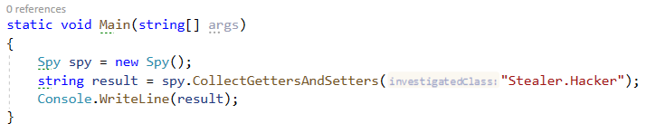

### Example

|  |
| --- |
| **Output** |
| get_Password will return System.String  get_Id will return System.Int32  get_BankAccountBalance will return System.Double  set_Password will set field of System.String  set_Id will set field of System.Int32  set_BankAccountBalance will set field of System.Double |